ANALOGS OF RECORDS: RELATIVE SEQUENTIAL SELECTIONS — RELAXED OR CONSTRAINED
PEICHAO PENG AND J. MICHAEL STEELE
Abstract. We consider selection processes that can provide either a multiplicative relaxation or a multiplicative constriction of the classical process of selected records in a sequence of independent observations. In the relaxed case, we find that the number of selections satisfies a CLT with a different normalization than R´enyi’s classical CLT for records, and in the constricted case we find convergence to an unbounded random variable with all moments. We also find refinements of some classical facts for the number of records in an independent sample, including an exact formula for the expected number of records given a specified level for the zero’th record. Further we note that a Markov chain central to our analysis has a stationary distribution that satisfies a non-autonomous pantographic equation.
Key Words. records, central limit theorem, R´enyi’s CLT for records, sequential selection, Dobrushin coefficient, pantograph equation, non-homogenous Markov chains.
Mathematics Subject Classification (2010). Primary: 60C05, 60G40,
90C40; Secondary: 60F99, 90C27, 90C39

Relaxed or Constrained Sequential Selection Processes
Let X_{i}, i = 1,2,... be a sequence of independent random variables with a common continuous distribution F with support in [0,∞), and let ρ denote a nonnegative constant. If we then set τ₁ = 1 and define a sequence of stopping times by taking
- τ_{k} = min{j : X_{j} ≥ ρX_{τk 1}} for k > 1,
−
then the random variables of main interest here are then given by
- R_{n}(ρ) = max{k : τ_{k} ≤ n}.
When ρ = 1 the times τ_{k}, k = 1,2,... are precisely the times at which new record values are observed, and R_{n}(1) is the total number of records that are observed in the time interval [1 : n] = {1,2,...,n}.
The random variable R_{n}(1) has been well understood for a long time. In particular, R´enyi (1962) found among other things that E[R_{n}(1)] ∼ logn and Var[R_{n}(1)] ∼ logn; moreover, he found that one has
- 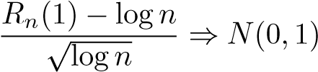,

Peichao Peng: Department of Statistics, The Wharton School, University of Pennsylvania, 3730 Walnut Street, Philadelphia, PA, 19104. Email address: ppeichao@wharton.upenn.edu.
J. M. Steele: Department of Statistics, The Wharton School, University of Pennsylvania, 3730 Walnut Street, Philadelphia, PA, 19104. Email address: steele@wharton.upenn.edu.
1
where, as usual, the symbol ⇒ denotes convergence in distribution and N(0,1) denotes the standard Gaussian distribution.
The cases ρ ∈ (0,1) and ρ ∈ (1,∞) seem not to have been considered previously, and they lead to some novel phenomena. First, the distribution of R_{n}(ρ) depends on F while in R´enyi’s case it does not. Moreover, one finds that in both of the new cases the asymptotic behavior is unlike the behavior that one finds for R´enyi’s classical record process {R_{n}(1) : n ≥ 1}.
The most interesting case is when ρ ∈ (0,1) where, in comparison to the classical record process, one has relaxed the condition that is imposed on sequential selections. In this case, one again has a central limit theorem, but the underlying process differs notably from R´enyi’s. In particular, the mean and variance grow linearly when ρ ∈ (0,1), and the summands are no longer independent.
Here, for the sake of brevity, we say a distribution function is in the selection class SL if there is an L ∈ (0,∞) such that F(0) = 0, F(L) = 1, and F is continuous and strictly monotone on (0,L). For example, the uniform distribution on [0,1] is in S1, and for any L > 0 the truncated exponential distribution F(x) = (1−e^{−x})/(1−e^{−L}) is in SL. For these examples, one has a density, but, in general, a distribution in SL need not have a density.
Theorem 1 (Mean, Variance, and CLT when 0 < ρ < 1). If X_{i}, i = 1,2,... are independent and if F ∈ SL, then there are constants µ_{ρ}(F) > 0 and σ_{ρ}(F) > 0 such that
- E[R_{n}(ρ)] ∼ nµ_{ρ}(F) and Var[R_{n}(ρ)] ∼ nσ_{ρ}²(F),
and one has a central limit theorem
- 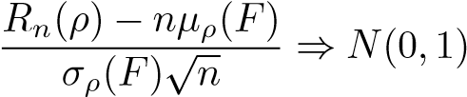.
After we develop some useful connections with the theory of Markov chains in Sections 2 and 3, the proof of Theorem 1 is given in Section 4. The main issues are the proofs of the relations (4) and the proof of σ_{ρ}²(F) > 0. Once these facts are in hand, the convergence (5) then follows from general theory; for example, one can obtain (5) directly from Arlotto and Steele (2016) Theorem 1, Corollary 2. Alternatively, with a page or two of extra work, one can obtain (5) by first generalizing other known central limit theorems for additive functionals of Markov processes. In either case, the proof that σ_{ρ}²(F) > 0 presents itself as the make-orbreak step.
For a general F ∈ SL, the task of determining the constants µ_{ρ}(F) and σ_{ρ}(F) seems intractable. Nevertheless, in leading case when F is the uniform distribution U on [0,1], there is an explicit series formula for the mean.
Theorem 2 (Moments for Uniform Distribution). If ρ ∈ (0,1) and if the random variables X_{i}, i = 1,2,... have the uniform distribution U on [0,1], then we have
(6) 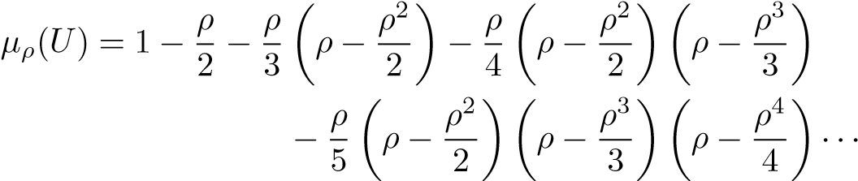
The proof of Theorem 2 is given in Section 5 and 6 where we also develop an equation of the pantograph type for the stationary distribution of the Markov chain given by the selected values. We do not solve this equation, but we use it to derive the Mellin transform for the stationary distribution. This is used in turn to get our formula (6) for µ_{ρ}(U). There is little hope of finding a correspondingly explicit representation for σ_{ρ}²(F) even for F = U. Nevertheless, we do find in Section 4 that there is a more abstract series representation (26) for σ_{ρ}²(F).
When ρ > 1, one no longer has a central limit theorem. Instead one has almost sure convergence to an unbounded non-negative random variable that has a wellbehaved moment generating function.
Theorem 3 (Distributional Limit when ρ > 1). If F ∈ SL and if F(x) = O(x) in the neighbourhood of 0, then for each ρ > 1 there exists an unbounded random variable N_{ρ} with moment generating function
- E[exp(sN_{ρ})] < ∞ for |s| < logρ,
such that with probability one R_{n}(ρ) ↗ N_{ρ} as n → ∞.
Sequential selection with ρ > 1 is notably less interesting than the cases with ρ = 1 or ρ ∈ (0,1) where one finds central limit theorems of two different kinds. Nevertheless, completeness calls for the consideration of ρ > 1, and we give a brief analysis of this case in Section 7.
Section 8 then develops several refinements of R´enyi’s classic formula for the expected number of records. For example, consider the number R_{n}^{x}(1) of records that are larger than x. When F is the uniform distribution on [0,1], we find
- 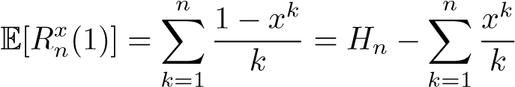.
This formula recaptures R´enyi’s classic harmonic sum when we set x = 0, yet the proof of (8) has nothing in common with the classic arguments of R´enyi (1962). Moreover, the methods that lead one to (8) yield further generalizations for the quantities E[R_{n}^{x}(ρ)] and lim_{n}{E[R_{n}^{x}(ρ)] − E[R_{n}^{y}(ρ)]}.
In Section 9 we examine more fully the senses in which the values chosen by the selection process (1) can be viewed as relaxed records, constrained records, or creatures of another breed. In particular, we note that in the relaxed case ρ ∈ (0,1), the selected values can differ greatly from any notion of approximate record, even though our sequential selection processes and various approximate record processes both contain the record process as a limiting cases when the time horizon is finite. Finally, in Section 10, we make brief note of three further connections between the theory of relative sequential selections and R´enyi’s theory of records.

Representation as a Markov Additive Functional
For k = 1,2,... we take Y_{k} to be the last value that has been accepted by the selection process during the time interval [1 : k]; that is, we set
Y_{k} = X_{τj} where j = max{m : τ_{m} ≤ k}.
The values Y_{k}, k = 1,2,... determine a Markov chain where if one is in state x then one stays in state x with probability F(ρx) and with probability 1−F(ρx) one moves to a point y in the set [ρx,1]\{x} that is chosen according to the probability measure dF(y)/(1 − F(ρx)). In other words, if we also set Y₀ = 0 then the process {Y_{k} : k ∈ [0 : ∞)}, has the transition kernel
- 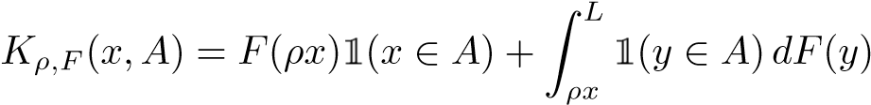.
Now, in terms of the Markov chain {Y_{k} : 0 = 1,2,...} we have the representation
n
- R_{n}(ρ) = ∑1[Y_{k} ≠ Y_{k−}1],
k=1
since we accept a new value precisely at the times when the state of the chain {Y_{n}} changes. Most of Theorem 1 follows from this representation after we establish a few analytic properties of the Markov chain {Y_{n}}.
Remark 4. Here one should note that by definition R_{n}(ρ) is a function of the independent random variables {X₁,X₂,...X_{n}}, and we simply write E[R_{n}(ρ)] and Var[R_{n}(ρ)] when R_{n}(ρ) is viewed in this way. On the other hand, by the representation (10), we can also view R_{n}(ρ) as a function of {Y₁,Y₂,...,Y_{n}} and the distribution of this sequence depends on the initial distribution of the Markov chain. When we take the second point of view it is natural (and necessary) to write Eµ[R_{n}(ρ)] and Var_{µ}[R_{n}(ρ)] whenever Y₀ has the distribution µ. By construction, we always have Var[R_{n}(ρ)] = Var₀[R_{n}(ρ)] and E[R_{n}(ρ)] = E0[R_{n}(ρ)].

The Dobrushin Coefficient and Its Consequences
There are several ways one can investigate the Markov chain defined by (9), but here it is especially efficient to first estimate its Dobrushin coefficient.
Definition 5 (Dobrushin Coefficient). If K is a Markov transition function on a Borel state space X and if B(X) denotes the collection of Borel subsets of X, then the Dobrushin coefficient δ(K) of the kernel K is defined by
.
Lemma 6 (Dobrushin Coefficient for K_{ρ,F}). If F ∈ SL and if K_{ρ,F} is the transition kernel given by (9), then one has
(11) δ(K_{ρ,F}) ≤ F(ρL) < 1.
Proof. If we assume x₁ < x₂, then for any Borel set A ⊂ [0,L] we have from (9) that
def
∆ = Kρ,F(x1,A) − Kρ,F(x2,A)
1 1
∫
∫
= F(ρx₁)1(x₁ ∈ A) +1 1(y ∈ A)dF(y) − F(ρx₂)1(x₂ ∈ A)− ∫ 1(y ∈ A)dF(y)
ρxρx₂ ρx₂
= F(ρx₁)1(x₁ ∈ A) − F(ρx₂)1(x₂ ∈ A) +1(y ∈ A)dF(y).
ρx₁
After majorizing the positive terms, we see from monotonicity of F that ∆ ≤ F(ρx₁) + {F(ρx₂) − F(ρx₁)} = F(ρx₂) ≤ F(ρL).
On the other hand, if we keep just the one negative term in the sum for ∆, then we have
∆ ≥ −F(ρx₂) ≥ −F(ρL),
and these two bounds on ∆ complete the proof of (11).
Nagaev (2015) proved that for any Markov chain with kernel K and Dobrushin coefficient δ(K) < 1, there is a probability measure ν on the state space X that is stationary under K, and, most notably, if K^{(n)} denotes the n step transition kernel, then one has the total variation bound
- |K^{(n)}(x,A) − ν(A)| ≤ 2[δ(K)]^{n} for all x ∈ X and A ∈ B(X).
Now, we let {Z_{n} : n = 0,1,2,...} be the Markov chain associated with the kernel K, and we write Ex and Eν for the corresponding expectation operators where accordingly as Z₀ = x ∈ X or Z₀ ∼ ν. By the total variation bound (12) and approximation by step functions, one can then check that for any bounded measurable g : D = X⁴ → R, one has for any fixed 0 ≤ i ≤ j ≤ k and n → ∞ that
- Ex[g(Z_{n},Z_{n+i},Z_{n+j},Z_{n+k})] − Eν[g(Z₀,Z_{i},Z_{j},Z_{k})] = O(||g||∞[δ(K)]^{n}), where here we set ||g||∞ = sup_{v}∈D |g(v)|.
The implied constant in (13) is absolute; in fact, it can be taken to be 4. Naturally, we also have analogous relations for functions of fewer than four variables or more than four variables. Here we only need (13) and its analog for functions of two variables.

When ρ < 1: Proof of Theorem 1
We now restrict attention to the Markov chain with transition kernel K_{ρ,F}(·,·) given by (9). By the bound (11) we have δ ≡ δ(K_{ρ,F}) < 1, so the stationary distribution exists. We consider two initial distributions: in the first case we take Y₀ ≡ 0; and in the second case we assume that Y₀ has the stationary distribution ν. By the two variable analog of (13) for g(Y_{n},Y_{n+1}) = 1(Y_{n} ⁼̸ Y_{n+1}) we have
- E0[1(Y_{k}−1 ≠ Y_{k})] = Eν[1(Y₀ ≠ Y₁)] + O(δ^{k}).
From (14) and the representation (10), we see by geometric summation that
n
- E0[R_{n}(ρ)] = ∑E0[1(Y_{k}−1 ≠ Y_{k})] = nEν[1(Y₀ ≠ Y₁)] + O(1)
k=1
= n∫ ∫ 1[s ≠ t]K_{ρ,F}(s,dt)dν(s) + O(1),
X X
where the double integral is just Eν[1(Y₀ ≠ Y₁)] written in longhand. This gives us the first assertion (4) of Theorem 1 in a form that is a bit more explicit; in particular, (15) tells us that in (4) we have
- µ_{ρ}(F) = ∫ ∫ 1[s ≠ t]K_{ρ,F}(s,dt)dν(s). X X
To find the asymptotic variance of R_{n}(ρ), we introduce two sequences of random variables:
U_{k} = 1[Y_{k−}1 ≠ Y_{k}] − E0(1[Y_{k−}1 ≠ Y_{k}]) and V_{k} = 1[Y_{k−}1 ̸= Y_{k}] − Eν(1[Y_{k−}1 ̸ =Y_{k}]).
Both U_{k} and V_{k} are functions of the Markov process {Y_{k} : k = 0,1,...}, so in particular, both {U_{n}} and {V_{n}} depend on the initial value Y₀. For clarity one should note that U_{k} has mean zero when Y₀ ≡ 0 and V_{k} has mean zero when Y₀ follows the stationary distribution ν.
The random variables U_{k} and V_{k} differ by a constant that depends on k, and by (14) the constant is not larger than O(δ^{k}). Thus, by the representation (10), we have
- .
Now, we expand the sum in (17) and write
- 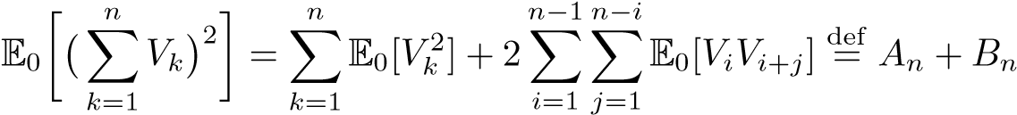.
To estimate the first sum A_{n} of (18), we apply (13) just as we did in the derivation of (14), and this time we find
.
Summation then gives us
- 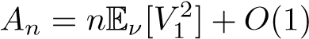.
To deal with the double sum B_{n}, we first need a lemma to help us estimate some of the summands of B_{n}.
Lemma 7. For any initial distribution µ one has
- Eµ[V_{i}V_{i+j}] = O(δ^{j}) for all i,j ≥ 0.
Proof. To exploit the Markov property for the chain {Y_{n} : n = 0,1,...}, we first condition on Y_{i}−1 and Y_{i} and note that
- Eµ[V_{i}V_{i+j}] = Eµ[V_{i}Eµ[V_{i+j} |Y_{i}−1,Y_{i}]] = Eµ[V_{i}Eµ[V_{i+j} |Y_{i}]] = Eµ[V_{i}EY_{i}[V_{j}]].
If we use (13) as before, then we see that for all x ∈ X we have
Ex[V_{n}^{] =} Eν[V_{n}] + O(δ^{n}),
and the implied constant does not depend on x. When we insert this into (21) and recall that the definition of V_{n} gives us Eν[V_{n}] = 0, the proof of the lemma is complete.
Lemma 7 helps us deal with cross terms with large j, but we also need a relation that deals with arbitrary j. Here, we again use (13) to get for all j ≥ 0 that
- E0[V_{i}V_{i+j}] = Eν[V_{i}V_{i+j}] + O(δ^{i}) = Eν[V₁V_{1+j}] + O(δ^{i}).
Now, to calculate B_{n}, we first apply Lemma 7 to the cross terms E0[V_{i}V_{i+j}] where i ≤ j and then apply (22) to the rest to obtain
- 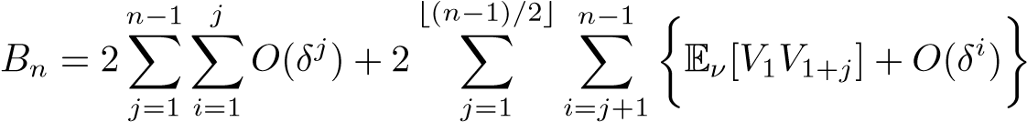.
We have the sums
n−1 j _{j} n−1 _{j} ⌊(n−1)/2⌋ n−1 _{i} n−1 _{j}
∑∑O(δ ) = ∑ O(jδ ) = O(1), ∑ ∑ O(δ ) = ∑ O(jδ ) = O(1)
j=1 i=1 j=1 j=1 i=j+1 j=2
and we have the sum
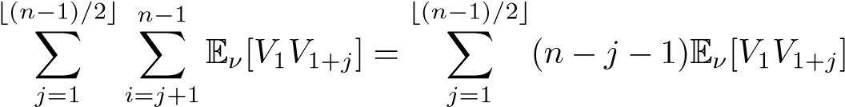,
so (23) becomes
- 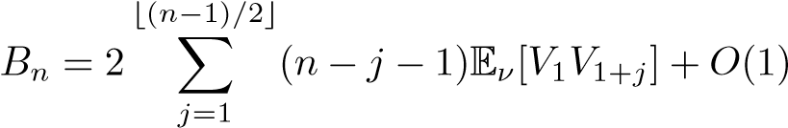.
In summary, (17), (18), (19) and (24) give us the key relation
,
and by Lemma 7 the summands are absolutely convergent, so we can take the limit in (25) to get
(26) 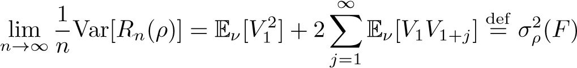.
This completes the proof of the asymptotic relations for the mean and variance of
R_{n}(ρ).
When these relations are coupled with the bound (11) on the Dobrushin coefficient, the rest of the proof of the central limit theorem of Theorem 1 is almost on automatic pilot. The key remaining step is the proof that the constant σ_{ρ}²(F) defined by (26) is strictly positive. Once this is done, the CLT (5) follows immediately from Theorem 1 of Arlotto and Steele (2016).
To work toward a lower bound for σ_{ρ}²(F), we let Fe be the σ-field generated by the evenly indexed terms Y₀,Y₂,Y₄,..., and, in order to facilitate calculations that are conditional on the “even σ-field” Fe, we write
n−1
R2n(ρ) = ∑ Wj where Wj = 1(Y2j+1 ≠ Y2j) + 1(Y2j+2 ≠Y2j+1).
j=0
We already know by (26) that Var[R_{n}(ρ)] = Var₀[R_{n}(ρ)] ∼ nσ_{ρ}²(F), and we have also shown that Var₀[R_{n}(ρ)] ∼ Var_{ν}[R_{n}(ρ)]. Thus, to show σ_{ρ}²(F) > 0, it suffices to show that there is a constant α > 0 such that Var_{ν}[R_{2n}(ρ)] ≥ nα for all n ≥ 1. We begin by studying the conditional variances of the individual summands of R_{2n}(ρ).
For specificity, we should also note that for each j the distribution of W_{j} given Fe does not depend on the initial distribution of the Markov chain; accordingly we simply write Var[W_{j}|Fe] for the corresponding conditional variance. On the other hand, the distribution of the random variable Var[W_{j}|Fe] depends on the distribution of Y₀, so, for its expectation when Y₀ ∼ ν, we need to write Eν[Var[W_{j}|Fe]].
Lemma 8. For all ρ ∈ (0,1) and F ∈ SL, there exists a constant α_{F}(ρ) > 0 for which one has
Eν[Var[W_{j}|Fe]] = Eν[Var[W_{j}|Y_{2j},Y_{2j+2}]] ≥ α_{F}(ρ) for all j ≥ 0.
Proof. When we condition on Fe = σ{Y₀,Y₂,...}, the distribution of W_{j} requires the consideration of two cases. First, if we have Y_{2j} = Y_{2j+2}, then with probability one we have Y_{2j} = Y_{2j+1} = Y_{2j+2} and hence W_{j} = 0. Second, given Fe with
Y_{2j} ≠ Y_{2j+2}, then we have
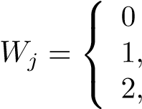
, with probability 0,
(27)with probability F(ρY_{2j}),
with probability 1 − F(ρY_{2j}).
From the representation (27) and the strict monotonicity of F ∈ SL, we see there is a constant C_{F}(ρ) > 0 such that for all j ≥ 0,
(28) Var[Wj |Y2j,Y2j+2] ≥ CF(ρ)1[Y2j ≠ Y2j+2, ρL ≤ Y2j,Y2j+2 ≤ L].
If we set Z = 1[Y_{2j} ≠ Y_{2j+2}, ρL ≤ Y_{2j},Y_{2j+2} ≤ L] and
A = {Y_{2j} ∈ [ρL,L]},B = {Y_{2j+1} ∈ [ρL,L],Y_{2j+1} ≠ Y_{2j}},C = {Y_{2j+2} ∈ [ρL,L]}.
Then Z ≥ 1(A ∩ B ∩ C) and
Eν[Z] ≥ P_{ν}(A ∩ B ∩ C) = P_{ν}(A)P_{ν}(B|A)P_{ν}(C|A,B).
Each term on the right hand side is at least 1 − F(ρL) because any upcoming observation that falls within [ρL,L] will be accepted. This gives us
Eν[Z] ≥ (1 − F(ρL))³,
so by (28) one can take α_{F}(ρ) ≡ C_{F}(ρ)(1 − F(ρL))³ > 0 to complete the proof of the lemma.
This is last of the tools we need to get a non-trivial lower bound for σ_{ρ}²(F). By the law of total variance and by Lemma 8, we have
Var[R_{2n}(ρ)] = E[Var[R_{2n}(ρ)|Fe]] + Var[E[R_{2n}(ρ)]|Fe]]
n
(29) ≥ E[Var[R_{2n}(ρ)|Fe]] = E∑Var[W_{j}|Fe]] ≥ nα_{F}(ρ)
[
j=1
where the last equality is due to the independence between W_{i} and W_{j} given Fe when i ≠ j.
Finally, given Lemma 8 and our earlier observations, the proof of Theorem 1 is complete.

Proof of Theorem 2
Before we take up the proof of Theorem 2 in earnest, it will be useful to know that when F is the uniform distribution we can work with the density of the stationary distribution of K_{ρ,F}. To get the required absolute continuity we begin with a general inequality.
Proposition 9. If F ∈ SL and if ν is the stationary measure for the transition kernel K_{ρ,F} given by (9), then for all Borel A ⊂ X one has
- 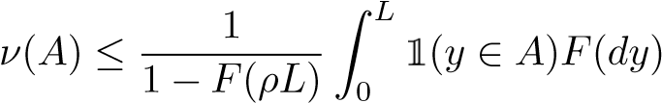.
Proof. Stationarity of ν and the definition of K_{ρ,F} give us
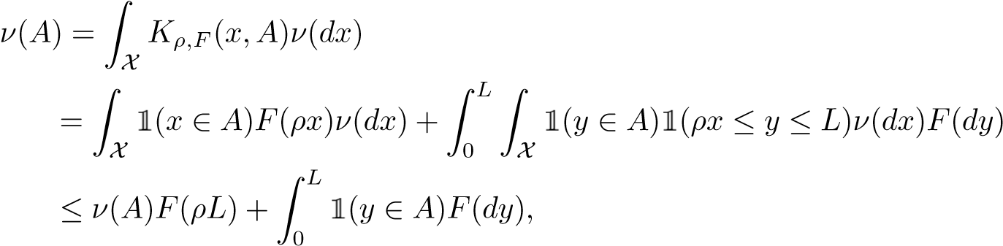
from which we get (30).
From (30) we see that ν is always absolutely continuous with respect to F. Consequently, if F is absolutely continuous with respect to Lebesgue measure dx, then both ν and F have densities with respect to dx.
Now we take F to be the uniform distribution on [0,1], and we simply write K_{ρ}, M_{ρ} and m_{ρ} for the corresponding transition kernel, stationary distribution function and density function. The definition of K_{ρ} and equation of stationarity now tell us
1 1
∫
m_{ρ}(y) =m_{ρ}(x)K_{ρ}(x,y)dx = ρym_{ρ}(y) + ∫ m_{ρ}(x)1(ρx ≤ y)dx,
0 0
or, in other words,
- m_{ρ}(y) − ρym_{ρ}(y) = M_{ρ}(y/ρ) for all y ∈ [0,1].
Perhaps the quickest way to extract what we need from this key identity is to first introduce the Mellin transform of m(·):
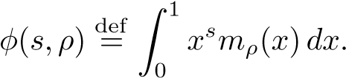
From (31) and the fact that M_{ρ}(x) = 1 for x ≥ 1 we then find
.
A change of variables and integration by parts give us
,
so (32) becomes
- 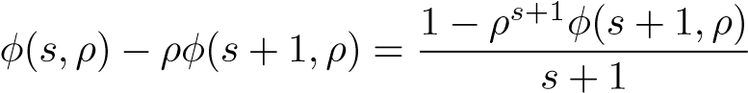,
which we can rewrite as a recursion,
- 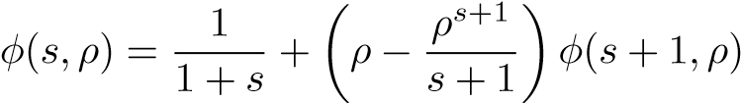.
Proposition 10 (Mellin Transform of the Stationary Density). We have
- 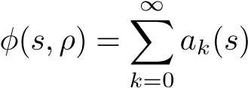 where 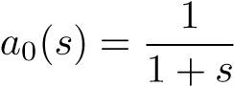 and
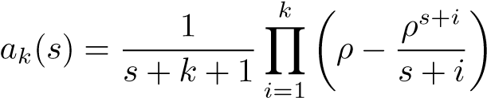 for k ≥ 1.
Proof. We just need to check that (35) satisfies the recursion (34). In fact we have
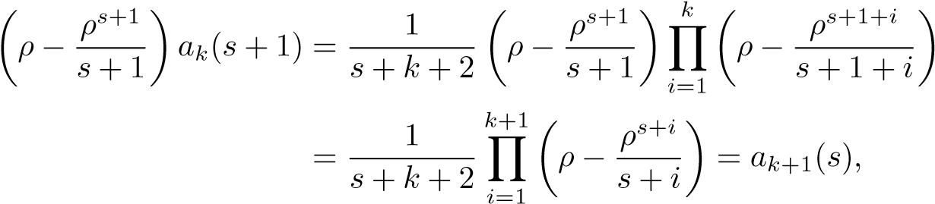
so summing from k = 0 to ∞ gives us
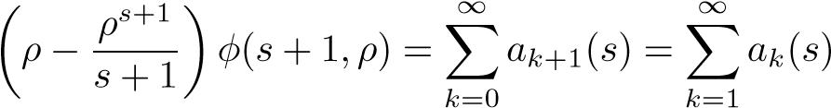.
Since a₀(s) = 1/(1 + s), we have proved
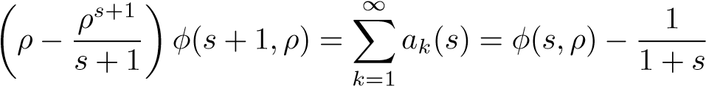,
giving us the required recursion (34).
For the first moment of m_{ρ}(·) we therefore find
,
and this is just what we need to complete the calculation of µ_{ρ}(U). Specifically, if we specialize the general formula (16) for µ_{ρ}(F) to the uniform distribution function U, we get some substantial simplification. Specifically, we have µ_{ρ}(U) = Eν[1(Y₀ ≠ Y₁)] =∫ K_{ρ}(x,y)1(x ≠ y)m_{ρ}(x)dxdy
∫
∫
1 1
- 0
- 11
=∫ 1(ρx ≤ y)m_{ρ}(x)dxdy = ∫ (1 − ρx)m_{ρ}(x)dx = 1 − ρϕ(1,ρ),
0 0 0 and, together with the expansion for ϕ(1,ρ), this completes the proof of the first assertion (6) of Theorem 2.
We will see in Section 6 that (31) is from an interesting class of equations with a long history and a rich theory. Nevertheless, there are situations where one can make use of (31) without knowing its solution and without appealing to the wider theory. Specifically, the next proposition illustrates the qualitative use of (31) and gives some properties that will be used in Section 10.
Proposition 11 (Features of the Stationary Density). The probability density m_{ρ}(·) on [0,1] that satisfies the equation of stationarity (31) is a continuous, strictly increasing function on (0,1). Moreover, it is strictly convex on (0,ρ) and strictly convex on (ρ,1], but it is not convex in any neighborhood of ρ. In particular, 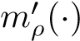has a jump discontinuity at ρ.
Proof. If we write (31) as m_{ρ}(y) = (1 − ρy)⁻¹M_{ρ}(y/ρ), then from the fact that y 7→ M_{ρ}(y/ρ) is non-decreasing and (1 − ρy)⁻¹ is strictly increasing, we see that m_{ρ}(·) is strictly increasing. Also, from the continuity of M_{ρ}(·) we see that m_{ρ}(·) is continuous, and, since M_{ρ}(·) is the integral of m_{ρ}(·), we see that M_{ρ}(·) is continuously differentiable. From M_{ρ}(0) = 0 and (31) we have m_{ρ}(0) = 0 from which we also find M_{ρ}′(0) = m_{ρ}(0) = 0.
For all x ∈ [1,∞) we have M_{ρ}(x) = 1, so (31) gives us an explicit formula
- 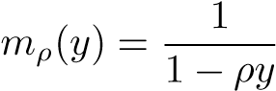 for y ∈ [ρ,1].
On the other hand, for y ∈ [0,ρ) the relation (31) is an integral equation which by differentiation gives us
- 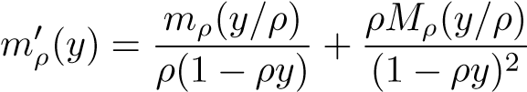 for y ∈ [0,ρ).
From (37) and the fact that m_{ρ}(·) and M_{ρ}(·) are both monotone non-decreasing, we find that m_{ρ}(·) is strictly convex on (0,ρ), while from (36) we see immediately that m_{ρ}(·) is strictly convex on [ρ,1].
To check that m_{ρ}(·) fails to be convex on [0,1], we first recall that we have m_{ρ}(1) = 1/(1 − ρ) and M_{ρ}(1) = 1, so by (31) and (37) the one-sided derivatives at ρ are given by
.
− − − −
This tells us that m_{ρ}(·) is not differentiable at ρ, and, moreover, since m′_{ρ}(·) has a negative jump discontinuity at ρ, we see that m_{ρ}(·) is not convex on [0,1].
As an application of the proposition, one should note that the jump discontinuity of m′_{ρ}(·) tells us that some plausible solution methods for (37) cannot work. For example, there can be no solution of (37) on [0,1] that is given by a power series (or a Frobenius series), even though we have the nice power series representation
(35) for the Mellin transform of m_{ρ}(·).

The Stationary Measure and the Pantograph Equation
The first-order non-autonomous pantograph equation for λ ∈ (0,∞) is the functional differential equation
- H′(t) = a(t)H(t) + b(t)H(λt) t ≥ 0.
The connection to the problems considered here is that for 0 < ρ < 1 the equation (31) for the distribution function M_{ρ} of the stationary measure of the transition kernel K_{ρ,U}(·,·) ≡ K_{ρ}(·,·) can be written as
- 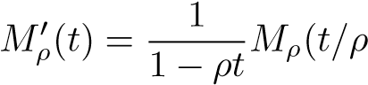) for 0 ≤ t < 1.
Thus, on the interval [0,1], the distribution function M_{ρ} satisfies the pantograph equation (38) with a(t) = 0, b(t) = 1/(1 − ρt), and λ = 1/ρ > 1.
The pantograph equation occurs in many contexts, perhaps the earliest of which was a number of theoretic investigations of Mahler (1940) that exploited the equation H′(t) = bH(λt), H(0) = 1 and its solution
- 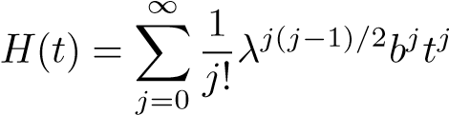,
which is an elegant — and useful — generalization of the exponential function.
The two-term pantograph equation (38) has mostly commonly occurred in the autonomous case where a(t) and b(t) are constant, and the equation got its name from Fox et al. (1971) where the autonomous equation was used to model the collection of current by the pantograph (or flat pan connection head) of a tram. The subsequent investigation of Kato and McLeod (1971) showed the full richness of the equation, and, ever since, the pantograph equation has been regularly studied and applied, see e.g. Iserles (1993), Derfel and Iserles (1997), Guglielmi and Zennaro (2003), Saadatmandi and Dehghan (2009), Yusufo˘glu (2010), and Hsiao (2015), all of which contain many references.
In the non-autonomous case, essentially all work on (38) has been asymptotic or numerical. Moreover, all of the recent work focuses on the case when λ ∈ (0,1), and there is a sound scientific reason for this. Specifically, for (38) to be useful in an engineering or scientific context, it seems natural to assume that it is a causal equation; that is, the current rate of change H′(t) is required to be determined by information that is available at time t.
A noteworthy feature of the stationarity equation (39) is that it is not a causal equation; one has λ = 1/ρ > 1. The other interesting feature of (39) is that it was essentially solved in Section 5, at least in the sense that Proposition 10 gives explicit series expansion of its Mellin transform.
Mellin transforms have rarely been used in the theory of the pantograph equation; we know of only one other case. Specifically, van Brunt and Wake (2011) used Mellin transforms to study a second order non-autonomous pantograph equation. Intriguingly, their equation was also acausal, and it also had a probabilistic origin. Specifically, it arose as the Fokker-Plank equation in a diffusion model for a population of cells, and the acausal parameter came from a splitting constant for cell division.
We do not make further use the pantograph equation here, but, given the richness of its theory, the connection seems worth noting. Benefits may even flow both ways. For example, calculations like those of Section 5 provide explicit Mellin transforms for the solutions of some other pantograph equations in addition to (39).

When ρ > 1: The Proof of Theorem 3
We now consider an infinite sequence X₁,X₂,... of independent random variables with distribution F ∈ SL. We then fix ρ > 1, and we again use the recursive definition (1) to specify the set of selection times {τ_{k} : k = 1,2,...}. If we then set
N_{ρ} = min{k : X_{τk} ∈ (L/ρ,L]} and M_{ρ} = min{τ_{k} : X_{τk} ∈ (L/ρ,L]}
then the number of selections one makes from {X₁,X₂,...,X_{n}} is simply given by
R_{n}(ρ) = R_{min(n,Mρ)}(ρ), since, after a selection larger than L/ρ has been made, no further selections are possible. Also, for each ω ∈ {ω : M_{ρ}(ω) < ∞}, we have
Rn(ρ) = Rmin(n,Mρ)(ρ) ↗ RMρ(ρ) = Nρ as n → ∞,
so the main task is to prove the moment generating function bound (7).
Since each value accepted by the selection process with ρ > 1 must be at least a factor of ρ greater than the preceding selection we have the bounds
N_{ρ} ≤ max{k : ρ^{k−1}X₁ ≤ L} ≤ 1 + logL/logρ − logX₁/logρ, so for the moment generating function we find
We know the integral is finite when F(x) = O(x) near 0 and |s| < logρ, and this gives us (7).
To show N_{ρ} is unbounded, we first fix an integer M > 1, and we consider the disjoint subintervals {I₁,I₂,...,I_{M}} of [0,L] that are defined by setting
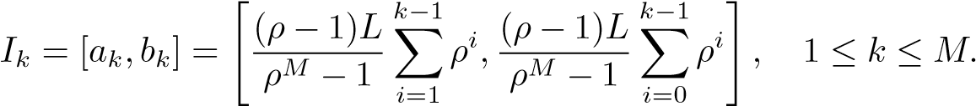
The main feature here is that one has a_{k+1}/b_{k} = ρ > 1 for all 1 ≤ k < M. If we have X_{i} ∈ I_{i} for i = 1,2,...M, then all of the observations X₁, X₂, ..., X_{M} are selected, so we always have the inequality
M
∏1(X_{k} ∈ I_{k}) ≤ 1(N_{ρ} ≥ M).
k=1
Finally, by the independence of the variables X_{k}, 1 ≤ k ≤ M and the strict monotonicity of F, we see that the expectation of the product is strictly positive. This gives us P(N_{ρ} ≥ M) > 0 for all M ≥ 1. Since M is arbitrary, we see that N_{ρ} is unbounded, and the proof of the theorem is complete.

Complements to Classical Record Theory
Here we consider the calculation of the expected number of selections where we assume that there was a selection made at “time zero” that had value x ∈ [0,1]. Formally, we modify the definition (2) by first setting τ₁ = min{j : X_{j} ≥ ρx}.
Next, for k ≥ 2 we define τ_{k} as before by setting τ_{k} = min{j : X_{j} ≥ ρX_{τk 1}}, and
−
finally we set
- .
In this notation, R´enyi’s classical formula for the expected number of records is
- 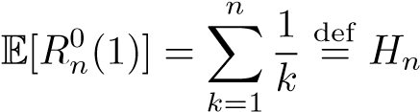,
and the main goal of this section is to generalize this result in two ways. The immediate goal is to show that
- 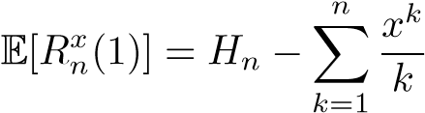,
and then in Theorem 12 we will get a closely related formula for E[R_{n}^{x}(ρ)]. We begin by using first step analysis to get a useful recursion for the quantities
g_{n,ρ}(x) def= E[R_{n}^{x}(ρ)] and g_{n}(x) ^{def}= g_{n,1}(x).
Specifically, if we consider the first observation y = X₁, then X₁ is not accepted if y ≤ ρx, and this happens with probability ρx. On the other hand if y = X₁ ∈ [ρx,1] we do accept X₁, and accordingly we find the basic recurrence relation
(44) 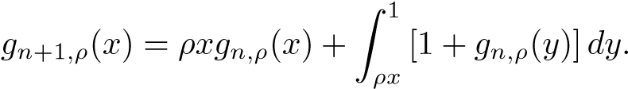
For general ρ ∈ (0,1), this equation offers considerable resistance; in essence, it is a linearized non-autonomous pantograph equation in integrated form. Nevertheless, one can use (44) to extract some interesting information, including refinements of some classical facts.
For example, if we take ρ = 1 in (44), then we can make some quick progress. Specifically, if we write g_{n}(x) for g_{n,1}(x) then differentiation and a nice cancellation give us
(45) 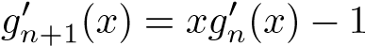.
We have 1 and repeated applications of (45) give us
, and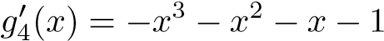.
In general, one has
(46),
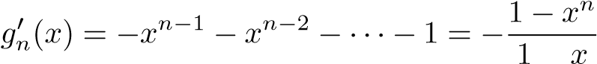
−
so integration over [0,x] gives us
- 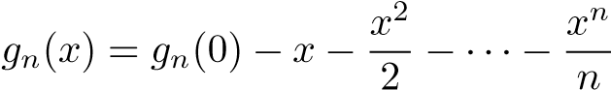.
Now if we use the basic recursion (44) with x = 0 and ρ = 1 we have from (47) that
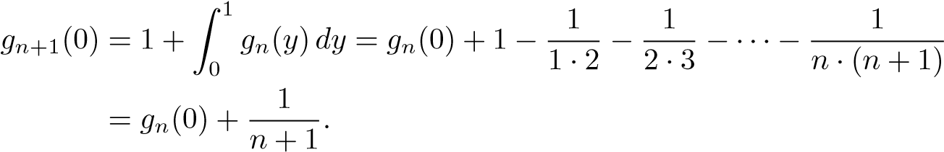
By telescoping we then recover R´enyi’s formula g_{n}(0) = H_{n}, but from (47) we now also find our refinement of R´enyi’s formula (and its approximation):
- 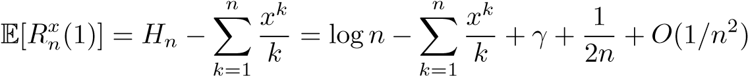,
where γ = 0.577··· is Euler’s constant.
For any 0 < ρ < 1, one can derive a representation of E[R_{n}^{x}(ρ)] that is only a little less explicit than (43). The correcting term is again a truncated power series, but, in the general case, the principal term g_{n,ρ}(0) is no longer a well-known quantity.
Theorem 12. For all 0 < ρ ≤ 1 and 0 ≤ x ≤ 1 we have
n
- gn,ρ(x) = gn,ρ(0) − ∑aixi,
i=1
where a₁ = ρ, a₂ = ρ(ρ − ρ²/2), and a_{i} = (ρ − ρ^{i}/i)a_{i}−1 for all i ≥ 2.
Proof. To argue by induction, we first recall that g_{1,ρ}(x) = ρx for all 0 ≤ x ≤ 1, and this gives us by direct evaluation that (49) holds for n = 1. Next, from the basic recursion (44) we have
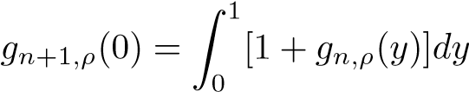 and 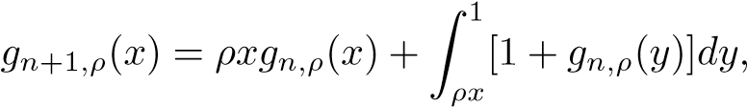
so taking the difference gives us
(50)
By the induction hypothesis we can expand the last integrand as
(51) 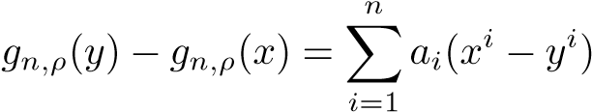,
so from (50) and the defining relation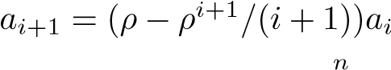 we have
.
Finally, from (50) and (52) we then get
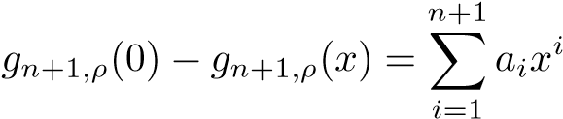,
which completes the induction step.
Since 0 < a_{i} ≤ ρ^{i}, the identity (49) has an immediate corollary that underscores an informative difference between the case when ρ ∈ (0,1) and the case when ρ = 1. Specifically, for ρ = 1 we see from (43) that the influence of x is unbounded, while the next corollary tells us that for 0 < ρ < 1 the influence of the initial value x has only a bounded influence.
Corollary 13 (Insensitivity of the Initial Constraint). For all ρ ∈ (0,1), n ≥ 0, and all 0 ≤ x ≤ y ≤ 1, one has
- 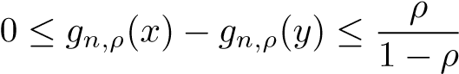.
The bounds (53) suggest that we should take limits, and from the geometric convergence in (51), we can define a continuous anti-symmetric function B : [0,1]² → R by setting
- 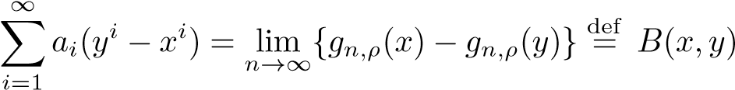.
A useful feature of this function is that it leads to an alternative characterization of µ_{ρ}(U), and it gives second proof of the series representation (6).
To derive the characterization, we subtract g_{n,ρ}(x) from both sides of the basic recursion (44), and we simplify to get the identity
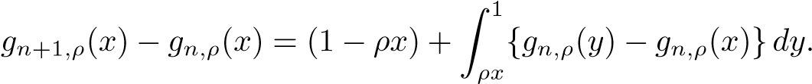
Now, if we set x = 0 in the defining relation (54) and apply antisymmetry of B(·,·), then we see that as n → ∞ one has g_{n+1,ρ}(0) − g_{n,ρ}(0) = 1 +B_{ρ}(y,0)dy + o(1) = 1 − ∫ B_{ρ}(0,y)dy + o(1).
∫
1 1
0 0
We now sum over n ∈ [0 : N]. By telescoping, division by N + 1, and taking limits we get a new formula for the mean µ_{ρ}(U) given by Theorem 2:
1
∫
(55) µ_{ρ}(U) = 1 −B_{ρ}(0,y)dy.
0
Finally, if we substitute the series expansion (54) for B_{ρ}(0,y) into (55), we see that term-by-term integration of (55) gives us a second derivation of the original formula (6) for µ_{ρ}(U). In a sense, this integration also explains the presence of the harmonic factors 1/2, 1/3, 1/4, ... in (6).

More Records: Relaxed or Constrained
For any ρ ∈ (0,∞) and any F ∈ SL, we can consider the set of selected values
A(ρ⁾ ⁼ {X_{τ1},X_{τ2},...}; these are formally defined by the stopping time recursion (1). The set A(1) is exactly the set of record values, and more generally we have the relations
(56) ρ ∈ (0,1) ⇒ A(1) ⊂ A(ρ) and ρ ∈ (1,∞) ⇒ A(ρ) ⊂ A(1),
which give us a more explicit sense in which ρ ∈ (0,1) relaxes the record condition and ρ ∈ (1,∞) further constrains the record condition.
The first relation of (56) is obvious since whenever X_{k} is a record, then we have X_{k} ≥ X_{τi} ≥ ρX_{τi} for all τ_{i} < k. It is rather less obvious that for ρ > 1 one has the complementary relation A(ρ) ⊂ A(1). To prove this by induction, we first note that X_{τ1} = X₁ ∈ A(ρ), and by definition X₁ is a record. Now we suppose by induction that the first n elements {X_{τ1},X_{τ2},...,X_{τn}} of A(ρ) are also all records.
There are two cases to consider. First, if τ_{n+1} < ∞ and X_{τn} = x, then we have τ_{n+1} = min{k : X_{k} ≥ ρx}. This tells us that τ_{n+1} is the first entrance time of the process X₁,X₂,... into the interval [ρx,L]. Since all such first entrance times are also record times, we see that X_{τn+1} is a record, and induction gives us A(ρ) ⊂ A(1). In the second case we have τ_{n+1} = ∞, and A(ρ) = {X_{τ1},X_{τ2},...,X_{τn}}. We already have from our induction hypothesis that {X_{τ1},X_{τ2},...,X_{τn}} ⊂ A(1), so again we get A(ρ) ⊂ A(1).
Despite the first relation of (56), it is generally inappropriate to think of the values A(ρ) = {X_{τj} : j = 1,2,...} are anything like “approximate records” when 0 < ρ < 1. To make this distinction explicit, fix 0 < ϵ < 1 and consider the events
(57) A_{k} = {X_{k} is selected and X_{k} ≤ ϵmax{X_{i} : i ≤ k}},
where the random variables X_{i}, i = 1,2... are independent and uniformly distributed on [0,1].
When A_{k} occurs, the selected value X_{k} is only a small fraction of the current maximum, so it is not an approximate record (or a near-record) in any reasonable sense. Nevertheless, with probability one, infinitely many of the events A₁,A₂,... will occur, so infinitely often the selected values are quite unlike records.
To see this, we first note by Proposition 11 that for any ϵ > 0 both of the sets [0,ϵ/2] and [1/2,1] have positive probability under the stationary measure ν for the associated Markov chain {Y_{n} : n = 1,2,...} of Section 2. Thus, they are also both recurrent sets for the chain. Now, if at time k the chain enters [0,ϵ/2] after having entered [1/2,1] at some time previous to k, then the event A_{k} also occurs. The positive recurrence of the respective sets then tells us that infinitely many of the events {A_{k} : k = 1,2,...} will occur with probability one.
This construction shows that there is a disconnection between the theory of the selection process with 0 < ρ < 1 and the theory of the near records such as studied in Balakrishnan et al. (2005), Gouet et al. (2007) or Gouet et al. (2012), but this construction does not tell the whole story. In Section 8 we saw several instances where the technology of selection processes could inform us about the classical record process. Still, it is reasonable to expect that one has at least some analogous carry forward to the theory of near-records, but here we cannot pursue that point except to acknowledge the possibility.

Connections and Directions
The theory of relative sequential selections lets one embed R´enyi’s record process into a parametric family of processes with a parameter ρ ∈ (0,∞) where the sequential selections are made easier when ρ ∈ (0,1) and where they are made harder when ρ ∈ (1,∞). If the horizon is finite, then the parametric processes have immediate contiguity relations; specifically, the finite dimensional distributions depend continuously on the parameter ρ. Still, as the table below reminds us, the processes show singular differences when ρ is fixed and n tends to infinity.
 | Expectation | Variance | CLT
ρ < 1 | ∼ nµ_{ρ}(F) | ∼ nσ_{ρ}²(F) | Yes
ρ = 1 | ∼ logn | ∼ logn | Yes
ρ > 1 | Convergence to random variable a.s.
There are several natural directions that have not been explored here. First, there are the issues of rates of convergence. In R´enyi’s case this is relatively easy, since one has access to the full theory of sums of independent random variables. On the other hand, it would be quite difficult to obtain a rate result when ρ ∈ (0,1) since even the basic CLT depends on the theory of functions of non-homogenous Markov chains.
Second, there is the possibility of related Poisson laws. Thus, for example, in R´enyi’s framework one can easily show that the number of records between time n and time 2n is approximately Poisson with mean λ = ln2. On the other hand, when ρ ∈ (0,1) the linear growth rate of the mean and variance tells us that as far as this example goes there is no directly analogous Poisson law. Naturally, there can be — and probably are — Poisson laws that are more distantly related.
Finally, one can consider the theory of selection processes where one does not require F to have compact support. Such extensions are feasible and interesting. Nevertheless, they are also intrinsically more complicated. For example, to guarantee good asymptotic behavior of the mean and variance of the number of selections when ρ ∈ (0,1), one probably needs to assume that the tail map x 7→ 1−F(x) has regular variation. Still, even with such an assumption, proper analogs of Theorems 1 and 3 are not easily formulated — or proved.

References
Arlotto, A. and Steele, J. M. (2016), ‘A central limit theorem for temporally nonhomogenous markov chains with applications to dynamic programming’, to appear in Mathematics of Operations Research (eprint arXiv:1505.00749) .
Balakrishnan, N., Pakes, A. G. and Stepanov, A. (2005), ‘On the number and sum of near-record observations’, Adv. in Appl. Probab. 37(3), 765–780. Derfel, G. and Iserles, A. (1997), ‘The pantograph equation in the complex plane’, J. Math. Anal. Appl. 213(1), 117–132.
Fox, L., Mayers, D. F., Ockendon, J. R. and Tayler, A. B. (1971), ‘On a functional differential equation’, J. Inst. Math. Appl. 8, 271–307.
Gouet, R., L´opez, F. J. and Sanz, G. (2007), ‘Asymptotic normality for the counting process of weak records and δ-records in discrete models’, Bernoulli 13(3), 754– 781.
Gouet, R., L´opez, F. J. and Sanz, G. (2012), ‘Central limit theorem for the number of near-records’, Comm. Statist. Theory Methods 41(2), 309–324.
Guglielmi, N. and Zennaro, M. (2003), ‘Stability of one-leg Θ-methods for the variable coefficient pantograph equation on the quasi-geometric mesh’, IMA J. Numer. Anal. 23(3), 421–438.
Hsiao, C.-H. (2015), ‘A Haar wavelets method of solving differential equations characterizing the dynamics of a current collection system for an electric locomotive’, Appl. Math. Comput. 265, 928–935.
Iserles, A. (1993), ‘On the generalized pantograph functional-differential equation’, European J. Appl. Math. 4(1), 1–38.
Kato, T. and McLeod, J. B. (1971), ‘The functional-differential equation y′ (x) = ay(λx) + by(x)’, Bull. Amer. Math. Soc. 77, 891–937.
Mahler, K. (1940), ‘On a special functional equation’, J. London Math. Soc. 15, 115–123.
Nagaev, S. V. (2015), ‘The spectral method and ergodic theorems for general Markov chains’, Izv. Ross. Akad. Nauk Ser. Mat. 79(2), 101–136.
R´enyi, A. (1962), ‘Th´eorie des ´el´ements saillants d’une suite d’observations’, Ann. Fac. Sci. Univ. Clermont-Ferrand No. 8, 7–13.
Saadatmandi, A. and Dehghan, M. (2009), ‘Variational iteration method for solving a generalized pantograph equation’, Comput. Math. Appl. 58(11-12), 2190–2196.
van Brunt, B. and Wake, G. C. (2011), ‘A Mellin transform solution to a secondorder pantograph equation with linear dispersion arising in a cell growth model’, European J. Appl. Math. 22(2), 151–168.
Yusufo˘glu, E. (2010), ‘An efficient algorithm for solving generalized pantograph equations with linear functional argument’, Appl. Math. Comput. 217(7), 3591– 3595.

